37.18: Starting from Eq. (37.22),
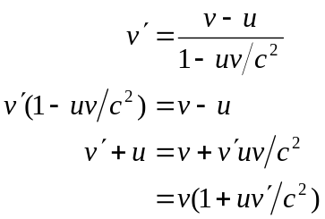
from which Eq. (37.23) follows. This is the same as switching the primed and unprimed coordinates and changing the sign of .

